Ideation Phase
Implement Client Script & UI Policy (Incident)

Date | 06 October 2026
Team ID | SWTID-2026-9105
Project Name | Implement Client Script & UI Policy (Incident)
Maximum Marks | 4 Marks

Implement Client Script & UI Policy (Incident):
The project focuses on implementing Client Scripts and UI Policies in ServiceNow to improve data integrity and enforce consistent behavior on Incident records. The team identifies the required UI controls, validation rules, automation, and testing scenarios needed to ensure that Incident records are complete, accurate, and handled consistently.
Use this project template to organize the requirements, implementation ideas, and validation priorities for the ServiceNow Incident configuration.
Reference: https://www.mural.co/templates/brainstorm-and-idea-prioritization
Step-1: Team Gathering, Collaboration and Define the Problem Statement
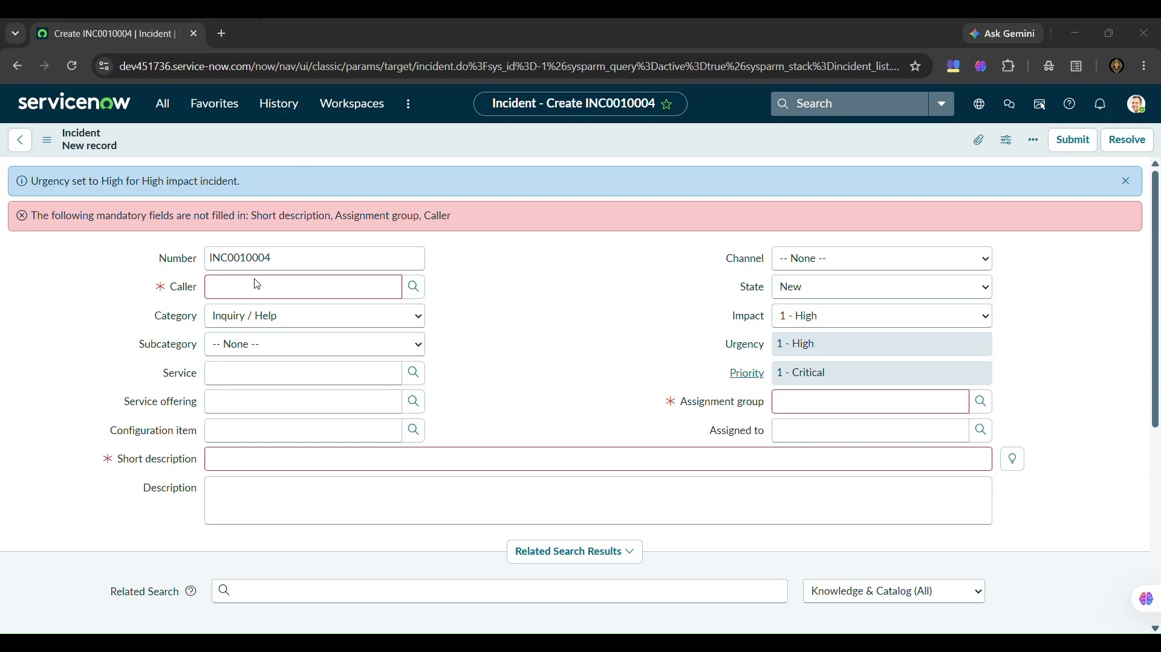

Step-2: Identify Client-Side Controls and Group Requirements
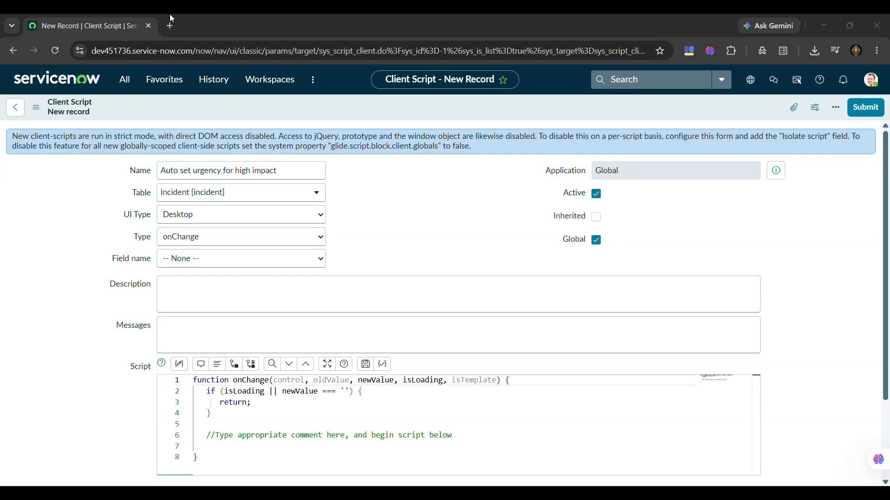

Step-3: Prioritize the Implementation Requirements
